**Homework Assignment 1**

Panteleimonas Chatzimiltis 1015742 – pchatz06

**Memory Hierarchy Measurements**

**For the following experiments I used the following machines from Winsconsin, with specifications (Both nodes were the same - c220g5):**

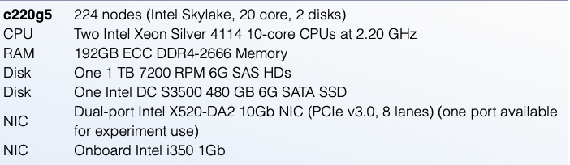

1. **Local Memory**
   1. To measure latency and bandwidth of the local memory (DRAM), I have used the mlc tool.
   2. Bandwidth measurement
      1. sudo ./mlc --memory_bandwidth_scan
      2. Average bandwidth found: 49845 MB/s
   3. Latency measurement
      1. sudo ./mlc --idle_latency
      2. Latency found: 0.09 us
   4. Total amount of memory
      1. cat /proc/meminfo
      2. Capacity: 187.6 GB
2. **Local Disk**
   1. To measure latency and bandwidth of the local disk, I used ioping for the latency and fio for the bandwidth.
   2. Bandwidth measurement
      1. fio --randrepeat=1 --ioengine=libaio --direct=1 --gtod_reduce=1 --name=fiotest --filename=testfio --bs=4k --iodepth=64 --size=1G --readwrite=read
      2. Bandwidth found: 252 MB/s
   3. Latency measurement
      1. ioping −c 20 /tmp/
      2. Latency found: 222.6 us
   4. Capacity
      1. sudo hdparm -I /dev/sda
      2. Capacity: 480 GB
3. **Remote Memory** 
   1. To measure network latency and bandwidth between the 2 nodes, I used ping for latency and iperf for bandwidth.
   2. Bandwidth measurement
      1. iperf −s −i 1 −w 4M -u (on node 0)
      2. iperf −c node0 −e −i 1 −u −b 10000000m (on node 1, I used big size to capture the maximum bandwidth)
      3. Bandwidth found: 4119 MB/s
      4. For the DRAM, I left it 4119 MB/s since it is the bottleneck between the actual DRAM’s bandwidth which is 49845 MB/s.
      5. For the Disc, I left it 251.8 MB/s since the bottleneck here is the actual Disc.
   3. Latency measurement
      1. ping node1 (on node 0)
      2. Average Latency found: 44 us
      3. For the DRAM, I added the network latency (44us) plus the DRAM’s latency
      4. For the Disc, I also added the network latency plus the Disc latency
   4. Capacity
      1. I did research of how to be able to find the capacity of the remote memory. I’ve tried several tools, like Prometheus, node_exporter.
      2. Later on, I thought I could be able to calculate it through the range of address space. However, this wouldn’t be possible because I do not have insights of how hypervisor is doing the translation to the physical addresses, and how big this space is.
      3. I assumed that they are the same as the initial measurement, since I used the same machine
4. **Result Graph**

**Observations:**

* As expected, local DRAM’s latency is much less than the local Disc or the remote Memory.
* The capacity of the DRAM, is less than Local disc.
* An interesting observation is that the latency to local Disc is bigger than the latency to the remote memory. On a VM, the latency to access local disc could be higher than accessing remote memory because disk includes file system, device drivers, etc. which adds an extra overhead. However, accessing remote memory especially on VM often utilizes optimized communication paths and protocols like RDMA, bypassing many of the layers involved in disk access and minimizing the latency.
* Accessing local DRAM has less latency than the Local disc or Remote Memory. DRAM, has direct communication with the physical memory (no translation needed to virtual), which is a lot faster, has minimal overhead compared to a disc access. Also, this difference in latency could be because, DRAM’s speed and the absence of layers present in a disc access.
* The bandwidth of disc is less than the remote memory bandwidth but not less than the DRAM’s latency.
* These observations can lead us to the conclusion that, sometimes it could be better to transfer files to remote memory than a local disc, especially on the VM’s case. Also, the capacity of the Remote Memory, is usually a lot more than local memory (Disc or dram).